|  |  |
| --- | --- |
| **Drug Delivery system**  **Submitted By- Darsh Mahajan | 12240500** | **Material Chemistry**  **(IC103)**  Academic Year 2022-23  Monsoon Semester  Submitted To-  Dr. Sanjib Banerjee  Instructor |

**Abstract**

It is the age of science, today in medical science drug delivery technology has enabled the production of many medical products that helps in recovery of patient health and reducing off target side effects by improving delivery of medicine to its target site.

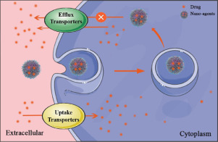I choose this topic so that I can learn more about medical science, specially in field of drug delivery system. In this term paper we will discuss about the Smart Materials and drug delivery system in human body

Huge smart materials have previously been created with stimulators like temperature, light, ultrasound, radiation, and magnetic fields for medication delivery or endogenous stimulators including pH, reactive oxygen species, hypoxia, and enzymes.

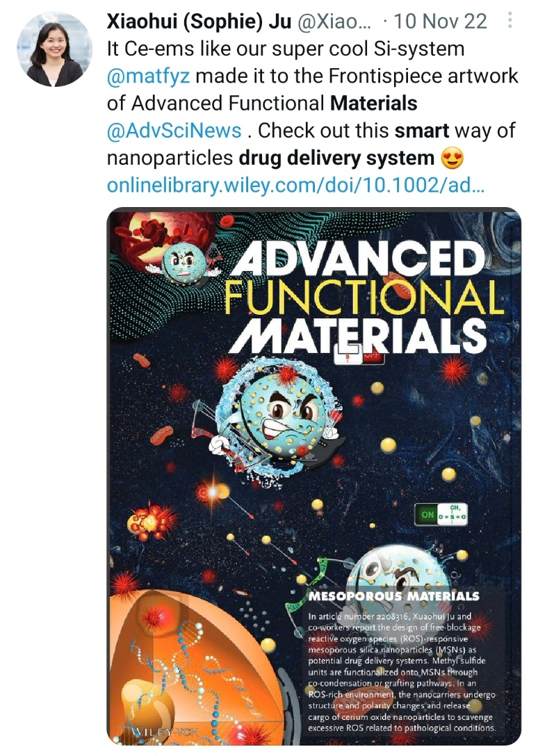

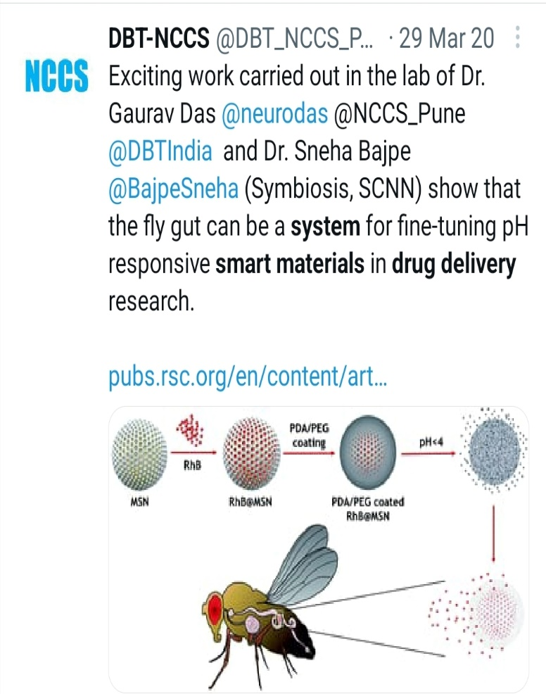

**Introduction**

By Drug Delivery System we meant the approaches, techniques and technologies involved in transportation of medicine to its target site by which we can cure the patient faster with less side effects, also a drug delivery system can be defined as mechanisms to introduce medicines into the body.

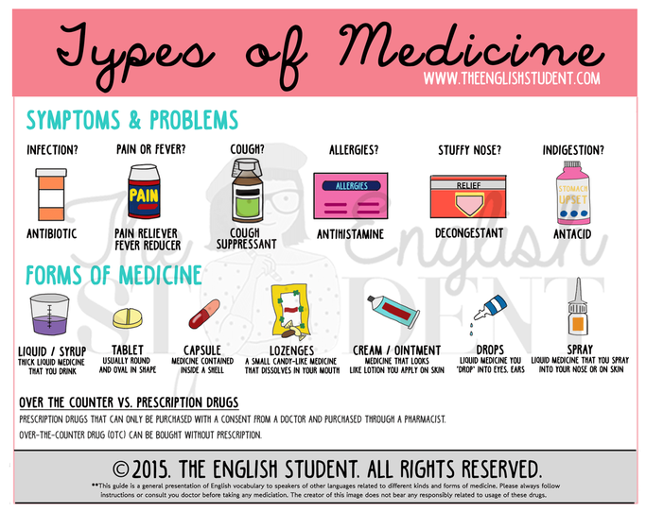In earliest time chewing leaves and roots of medical plants and inhalation of soot from the burning of medical substances used for medical treatment, these are also examples of drug delivery. However this method lacked a very basic need in drug delivery that is, consistency and uniformity (amount of drug dose). In the methods of drug delivery like pills, syrups, capsules, tablets, elixirs, solutions, extracts, emulsions, suspension, cachets, troches, lozenges, nebulizers etc come in existence.

The modern era of medicine development started with the discovery of vaccines in 1885 followed by the introduction of penicillin after its discovery in 1929, The development and production of many medical drugs involves the genetic modification of microorganisms to transform them into drug-producing factories. It is now possible to produce peptide, and protein drugs. Each of these drugs, by virtue of size, stability, or the need for targeting, requires a specialized drug delivery system

Development of new medicinal drug molecule is expensive and time consuming so Improving safety efficacy ratio of “old” medicines has been attempted using different methods such as dose titration, and drug monitoring. Delivering drug at controlled rate, slow delivery, targeted delivery are other very effective methods and have been used various times.

Similar advancements with other substances have given rise to a myriad of new tools, ideas, and methods together referred to as controlled-release technology (CRT). CRTs include a range of programmable, implanted drug-delivery devices as well as transdermal and transmucosal controlled-release delivery systems, ml6 nasal and buccal aerosol sprays, drug-impregnated lozenges, encapsulated cells, oral soft gels, and drug-impregnated lozenges.

The proper amount of the active substance must be absorbed and delivered to the site of action at the appropriate time to create the concentrations necessary to produce a specific therapeutic response required to sustain the effect's level for whatever long is required. The administration of the medication to tissues other than the organs and sites of action is wasteful, unneeded, and might result in toxicity. The change of the medication delivery method through the preparation and projection of new, cutting-edge drug delivery devices can enhance therapy. Numerous drug delivery methods have been developed since the 1960s, when silicone rubber was proposed as an implanted carrier for sustained distribution of low molecular weight medicines in animal tissues.

**Methodology**

For all drugs, the goal of delivery is to maximize medical effectiveness by transporting and releasing the drug (passively or actively) to the target site in the body and by minimizing off-target accumulation of the drug. Controlling medication PKs, lowering drug toxicity, boosting the drug's accumulation at the target location, and enhancing patient compliance and acceptability can all help with this. The identification of specific delivery issues associated with each class of treatment has sparked innovation in delivery methods and techniques.

Drug Delivery System can be divided into two parts

1. Conventional Drug Delivery System
2. Novel Drug Delivery System

**Conventional Drug Delivery System**

It is the classical method for the delivery of Drugs into the Body

The examples of this systems are

* Oral Delivery
* Buccal Delivery
* Rectal Delivery
* Intravenous Delivery
* Sub Cutaneous Delivery

**Novel Drug Delivery System (NDDS)**

It combines modern technology, innovative dose forms that are far superior to traditional dosage forms, and medical equipment.

It increases medication potency, regulates drug release to offer a long-lasting therapeutic impact, increases safety, and particularly targets a drug to a targeted tissue.

Types of NDDS are:

* Targeted Drug Delivery System
* Controlled Drug Delivery System
* Modulated Drug Delivery System

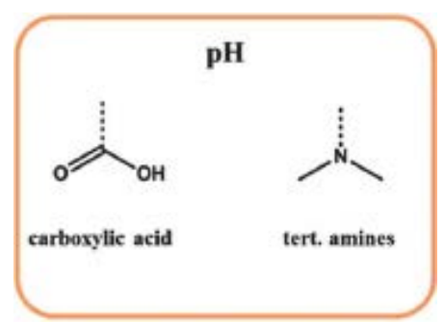**Smart Materials in Drug Delivery System**

* **pH-responsive smart materials:**

Polymers that are pH sensitive or pH responsive will alter in size in response to changes in the pH of the surrounding media. Depending on the pH of their surroundings, materials might inflate, collapse, or undergo other changes. Due to Acidic group (-COOH, -SO3H ) and Basic group (-NH2 )

Ex: 1. Poly ( acrylic acid)

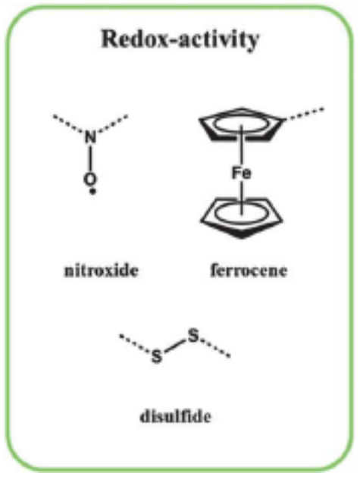 2. Poly ( methacrylic acid)

* **Redox-triggered smart materials:**

The most crucial stimuli for disease therapy are redox-responsive ones, which are also frequently used in polymer drug delivery systems. A high concentration of GSH easily cleaves the di-sulphide linker because it is reduction-sensitive.

* **Temperature-responsive smart materials:**

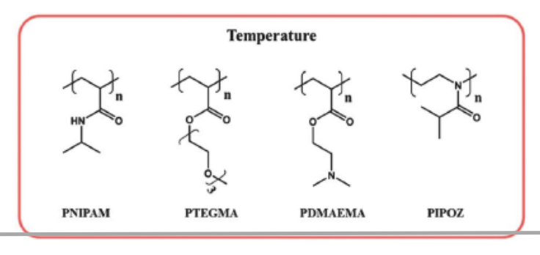Temperature-responsive polymers (TRP) are polymers that vary dramatically and abruptly with temperature in terms of their physical characteristics. The phrase is frequently used to refer to a property's solubility in a particular solvent, but it can also be used to refer to other qualities that are impacted. At a Critical Solution Temperature (CST) phase of solution and polymer is changes

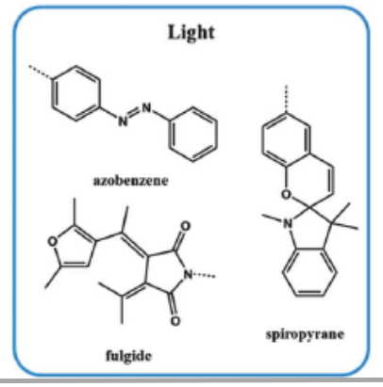It is of two types 1) TRP which shows Upper CST 2) TRP which shows Lower CST

* **Light-responsive smart materials:**

Photo-responsive polymers are a class of materials that can be triggered by radiation Depending on the type of radiation used, the structure of the polymer, and the environment, the response of the polymer can vary.

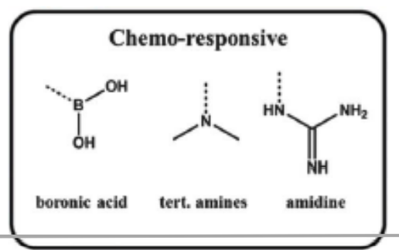

* **Chemo-Responsive:**

Chemo-responsive polymer materials are structures that adapt to a chemical substance acting as an external stimulus. This behaviour may appear as a change in the volume shape of the material or as a change in the material's inherent characteristics, such as its optical, mechanical, etc.

**Discussion**

In response to a variety of endogenous stimuli, different stimuli-responsive polymers have been developed to deliver the anticancer medicines. While the external stimuli-responsive system requires prior information of the location of the target site for effective therapy, the endogenous stimuli-responsive system relies on the aberrant microenvironment in sick tissues for target-specific medication delivery. It has been investigated to use various polymers to create various stimuli-responsive medication delivery systems. Stimuli-responsive polymers' ability to be used in medicine is anticipated to be hampered by their challenging production and scaling issues. This is one of the key explanations for why numerous stimuli-responsive polymers have been reported but only a small number of them have reached the clinical level.

**Future Scope**

Future applications for nanomedicines focus on creating multifunctional drug delivery nano-systems by combining several stimuli. To make cancer therapy visual trackable, combining diagnostic and therapeutic substances may be used. We predict that multifunctional drug delivery nano-systems for cancer therapy will soon be created for real-world therapeutic uses.

Smart materials will be used in drug delivery systems in the future to:

1 improve drug targeting accuracy to specific cells or tissues; and

2 improve drug efficacy and side effects.

3 Personalized medication using customised drug delivery methods

4 long-lasting treatments for persistent ailments

5 Creation of implanted gadgets for continuous drug delivery

6 Development of new therapeutic spheres like gene and immunotherapy

7 Combining sophisticated technologies like nanotechnology and biotechnology with smart materials.

**References**

* Wikipedia
* YouTube
* Google Images
* Class Notes
* Twitter
* Google News